**Student Name**: Simran

**Course**: Software Project Management

**Journal URL**: <https://github.com/simran6520/Software-Project-Management>

**Week 1**: January 18 - January 24

**Date**: January 24, 2024

**Key Concepts Learned**:

This week's sessions focused on the diverse nature of project initiation, planning, monitoring, control, and closure, emphasizing the applicability across various project types like road construction, building development, and software products. Special attention was given to software project management, highlighting the need for specialized skills in software engineering, testing, and design.

Characteristics of project:

* Planned
* Aiming at a specific target
* Work carried out for a customer
* Constrained by time and resources
* Non-routine

Software tasks in software projects

* Requirement management
* Design management
* Source code building
* Software testing
* Software deployment
* Software maintenance

Further, the crucial aspects of project initiation were discussed.

A detailed project scope is developed to define boundaries of the project. The scope will include what functionalities are needed in the software product to be developed. It will also define level of quality needed in the software product.

Project charter is made by the top management of the organization for starting a software project. Project charter basically defines the purpose for starting the project

The importance of accurate estimation of task duration, identification of task dependencies, and the subsequent creation of a baseline schedule were emphasized.

Software project initiation tasks

* Initial schedule estimates
* Project charter
* Project scope
* Project objectives
* Initial effort estimates
* Initial cost estimates

Project consumes

* Resources
* Budget
* Time

* A software project will have processes like software life cycle processes (requirement gathering, software design, software construction, software testing etc.), software project processes, software configuration management

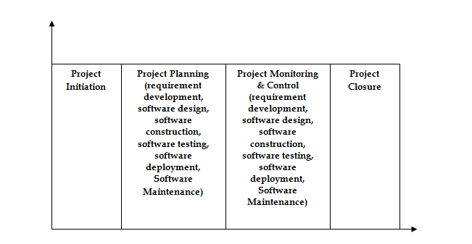

Objectives of Project should be SMART

**S** – specific, that is, concrete and well-defined

**M** – measurable, that is, satisfaction of the objective can be objectively judged

**A** – achievable, that is, it is within the power of the individual or group concerned to meet the target

**R** – relevant, the objective must relevant to the true purpose of the project

**T** – time constrained: there is defined point in time by which the objective should be achieved

**Application in Real Projects**:

Project scheduling principles have broad implications in a variety of fields and real-world contexts. Many fields can benefit from the application of the techniques covered in this discussion, which include precise job length prediction, task dependency identification, baseline schedule development, and the project division technique.

1. Construction Industry: Managing processes like excavation, foundation laying, and structural construction in construction projects requires precise scheduling. It is essential to have task dependencies, such as finishing the foundation before building the walls. Establishing baseline schedules makes it easier to monitor development and modify schedules in response to site conditions. Before granting building contracts, the project division technique can also be used to estimate effort and costs with the help of experts.

2. Information Technology and Software Development: Precise scheduling is crucial to software initiatives. It is essential to estimate the amount of time needed for the coding, testing, and debugging stages. A smooth workflow depends on task dependencies, such as finishing software design before coding. Software development projects use baseline schedules as a point of reference to monitor progress, and the project division technique can be used to obtain expert estimates prior to outsourcing development work.

3. Healthcare Sector: Project scheduling is essential for bringing new technologies, such electronic health record (EHR) deployments, to life in the healthcare sector. It's critical to estimate the time needed accurately for workflow modifications, system integration, and staff training. Task dependencies are important, such as finishing training prior to system rollout.

**Peer Interactions:**

In our software project management class, we had a lively peer interaction session where we discussed our project plans and strategies for effective project execution. I collaborated with my classmates to review our project schedules, identify potential risks, and brainstorm mitigation strategies.

**Challenges Faced**:

Encountered challenges in reconciling general project management concepts with the intricacies of software development. Further clarification is needed on how metrics and tools can be tailored for effective software project control and monitoring.

Mastering project scheduling involves overcoming difficulties with precise work time estimation, managing dependencies, and fine-tuning preliminary schedules. Coordination is a hurdle when putting the project division technique into practice, and expert estimates must be seamlessly integrated into the bidding process. The ability to be flexible and solve problems is necessary when applying theory to real-world situations.

**Personal Development Activities**:

Supplemented class materials by reading case studies on the integration of software engineering practices into project management.

**Goals for the Next Week**:

1. Explore case studies that demonstrate cost estimation in project management.
2. Dive deeper into the risk management for the project management as risk can hamper a project either affecting product quality or rate of production.

**Week 2:** January 28 – February 3

**Date**: February 3, 2024

**Key Concepts Learned:**

**Effort & Cost Estimation**

**Some Popular Experience-based estimation approaches**

* Estimation by Analogy
* Estimation by Expert Judgment

**Estimation by Analogy:**

**Step 1:** Get detailed size results for a similar previous project.

**Step 2:** Compare the size of the new Project to a similar past project.

**Step 3:** Build up estimate for the size of the new project.

**Step 4:** Create an effort estimate based on the size of the new Project.

**Estimation by Expert Judgement:**

1. Function point count for effort estimate (function point analysis technique)

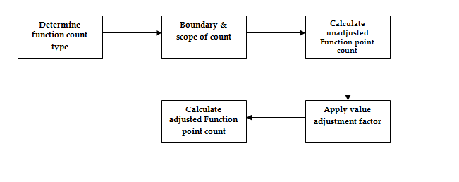

1. Function count type for effort estimate (function point analysis technique)

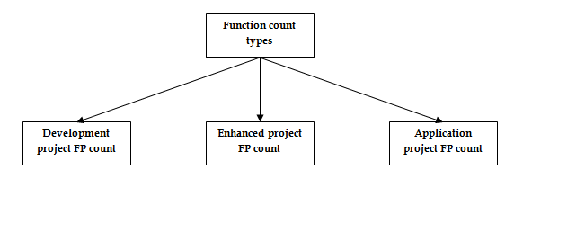

1. Effort sizing for effort estimate (function point analysis technique)

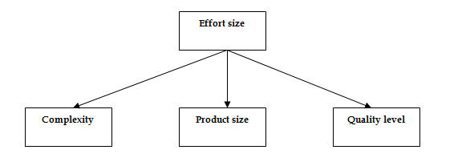

1. Effort estimates for iterative projects

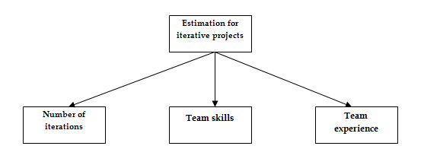

**Function points analysis**

Function point metrics provide a standardized method for measuring the various functions of a software application.

**FPA Components**

COCOMO cost modeling

The basic CoCoMo model assumes that the effort is only a function of the number of lines of code and some constants evaluated according to the type of software system.

Risk Management:

Risk assessment:

1. Risk Identification
2. Risk analysis
3. Risk prioritization

Major risk types on projects

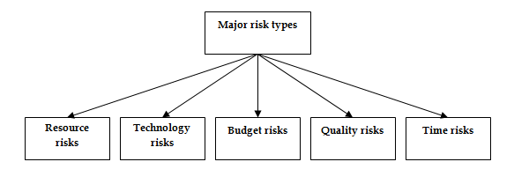

**Risk control**

* Risk planning.
  + Can be performed at the beginning of the project development and reassessed at the beginning of the iterations.
* Resolution
  + The assignment of a risk item to a person/ date by which it has to be

resolved.

* + Can be performed throughout the project development.
* Risk monitoring.
  + Can be performed throughout the project development.

**Reflections on Case Study/course work:**

From the case study discussed in class, we learned

Testing Is Important: Extensive testing is essential to the success of complicated projects, particularly when introducing new logic. Prioritizing testing and allocating sufficient resources are necessary to guarantee the software's quality and dependability.

Effort estimate: Accurately evaluating the effort needed for project components can be achieved by employing bottom-up effort estimate methodologies. An estimate of overall effort that is more realistic is obtained by dissecting functionality into smaller components and calculating the effort required for each one.

Contract negotiation: Thorough assessment and discussion with service providers can result in advantageous agreements that satisfy the demands of the project with regard to expenses, calibre, and sustainability over the long run.

Thorough Risk Assessment: It's critical to recognize any hazards early on in the project's lifecycle. This case study proactively identified risks related to software quality, development expenses, schedule delays, attrition, software quality, and viability of offshore teams.

cooperation and Communication: Managing remote teams requires effective cooperation and communication, particularly when working with offshore teams in various time zones. To reduce communication gaps and promote collaboration, standardize communication processes, use virtual meetings, and make use of a variety of communication tools.

**Collaborative Learning:**

During collaborative learning, we discussed the market analysis phase and collaboratively created a market survey form to facilitate our market analysis efforts.

**Peer Interactions:**

In our software project management class, we had a lively peer interaction session where we discussed our project plans and strategies for effective project execution. I collaborated with my classmates to review our project schedules, identify potential risks, and brainstorm mitigation strategies.

**Personal development activities:**

Engaged in learning sessions focused on effort estimation techniques like FPA, COCOMO, and Wide Band Delphi to enhance my project planning skills.

**Adjustments to Goals:**

Complete 1st and 2nd chapter in 1st week and gone through 3rd chapter in 2nd week. Also done market analysis through survey form for project.

**Goals for the Next Week:**

Reading risk management chapter and going to work on project initiation.

**Week 3:** February 4 – February 10

**Date**: February 10, 2024

**Key Concepts Learned:**

**Risk Management**

* Risk: The combination of the probability of an event and its negative consequence.

**Risk assessment:-**

1. **Risk Identification**
2. **Risk analysis**
3. **Risk prioritization**

**Major risk types on projects**



**Causes of risks**

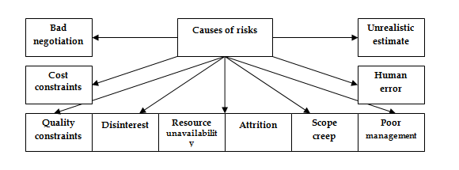

**Risk assessment:**

* **Risk identification**: Identify risks related to the overall project, to the product and to the business.
* **Risk Analysis**:

Assess:

* + the likelihood of occurrence
    - **Qualitative: Scale** (for example: **Low, Moderate, Significant, High**)
    - **Quantitative: probability of occurrence**
  + the impact on project, product, and business of each risk item
    - **Qualitative: Scale** (for example: **Low, Moderate, Significant, High**)
    - **Quantitative:** where data is available.

– *Example: fire can cause* ***0.5 millions*** *of damage in a facility*

* **Risk Prioritization**:

Once risk items have been identified and analyzed (in terms of their likelihood of

occurrence and impact), we need to set priorities to determine where to

focus risk mitigation efforts.

**Risk Control:**

* Risk planning
  + Can be performed at the beginning of the project development and reassessed at the beginning of the iterations
* Resolution
  + The assignment of a risk item to a person/ date by which it has to be

resolved.

* + Can be performed throughout the project development
* Risk monitoring

Can be performed throughout the project development

**Configuration Management**

Software product features need to be changed if end users make a request. This is not unusual and is a common practice on software projects. There could be many change requests during the entire project duration.

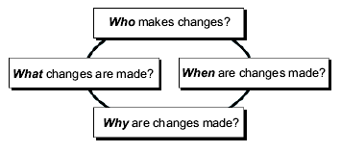

Benefits of CM to a Project: -

1. Reduces confusion and establishes order.
2. Organizes the activities necessary to maintain product integrity.
3. Ensures correct product configurations.
4. Limits legal liability by providing a record of actions.
5. Reduces life-cycle costs.

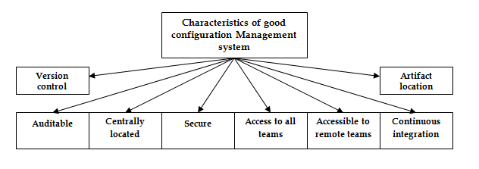

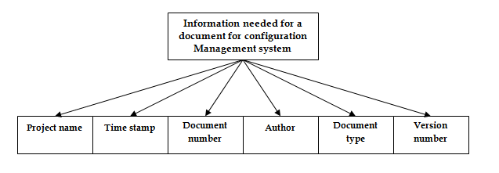



**Purpose of Configuration Management: -**

* To establish and maintain the integrity of work products using:
  1. configuration identification,
  2. configuration control,
  3. configuration status accounting

**Reflections on Case Study/course work:**

I participated in case study focusing on risk management in software development projects. The case study presented a scenario where a software development team faced unexpected delays and cost overruns due to inadequate risk management practices. Analyzing this case study provided valuable insights into the importance of proactive risk identification, analysis, and mitigation in software project management.

One key insight I gained from this activity is the critical role of stakeholder engagement in effective risk management. In the case study, it became evident that the failure to involve key stakeholders early in the risk management process led to overlooking potential risks and their impacts on project outcomes. This resonated with the course content, particularly discussions on stakeholder management and communication strategies.

**Collaborative Learning:**

Throughout the week, I engaged in several collaborative activities with my peers in the software project management course, focusing on risk management and configuration management.

One particularly beneficial group activity was a project, where we collectively brainstormed and documented potential risks associated with our hypothetical software project. Working with peers from diverse backgrounds allowed for a comprehensive exploration of risks from various perspectives, helping us uncover potential blind spots and develop a more robust risk management plan.

**Further Research/Readings:**

In addition to the course material, I explored several resources this week to enhance my understanding of risk management and configuration management in software project management:

“Software Configuration Management Handbook” by Alexis Leon: This comprehensive handbook provided in-depth coverage of configuration management principles, processes, and tools. I found the chapters on version control systems and change management particularly insightful, offering practical guidance on implementing effective configuration management practices.

“Risk Management in Software Development and Software Engineering Projects” by John W. Chard: This research paper explored advanced techniques for identifying, analyzing, and mitigating risks in software development projects. The case studies presented in the paper illustrated how proactive risk management can significantly improve project outcomes and mitigate costly delays and failures.

**Adjustments to Goals:**

Reflecting on the goals set for the previous week, I recognize the need to prioritize gaining practical experience with risk management and configuration management tools. While I have developed a solid theoretical understanding of these concepts through coursework and supplementary readings, I believe hands-on experience will further reinforce my learning and prepare me for real-world project management scenarios.

**Peer Interactions:**

Knowledge Exchange: Interacting with peers facilitated a rich exchange of knowledge and experiences. By discussing risk management strategies and configuration management practices with classmates, I gained exposure to diverse perspectives and practical insights that I may not have encountered on my own. This collaborative environment fostered a deeper understanding of complex concepts and encouraged critical thinking.

**Applications in Real Projects:**

**Problem Solving**: The collaborative activities helped me develop effective problem-solving skills that are essential in real-life project management scenarios. By working with peers to identify risks and devise mitigation strategies, I gained practical experience in navigating complex challenges and making informed decisions under uncertainty. These skills are directly applicable to real-world projects where risk management plays a crucial role in ensuring project success.

Communication and Collaboration: Interacting with peers enhanced my communication and collaboration skills, which are indispensable in professional settings. Through group discussions and teamwork, I learned to articulate ideas clearly, actively listen to others, and negotiate consensus. These interpersonal skills are invaluable when collaborating with cross-functional teams, stakeholders, and clients in real-life projects.

Personal Development Activities:

**Reflection and Self-Assessment:** Engaging in peer interactions prompted self-reflection and self-assessment of my strengths and areas for improvement. By actively participating in group activities and seeking feedback from peers, I gained valuable insights into my communication style, teamwork abilities, and leadership potential. This self-awareness is crucial for personal development and professional growth.

**Continuous Learning**: Collaborating with peers fueled my enthusiasm for continuous learning and professional development. Recognizing the rapid pace of change in the software industry, I am committed to staying abreast of emerging trends, best practices, and technological advancements. By leveraging peer interactions as a catalyst for learning, I can expand my skillset and adapt to evolving challenges in the field of software project management.

**Adjustments to Goals:**

Complete 4th and 5th chapter in 3rd week. Also done problem identification and market analysis for project.

**Goals for the Next Week:**

Reading project planning chapter and going to work on project.

**Week 4:** February 11– February 17

**Date**: February 17, 2024

**Key Concepts Learned:**

In project planning phase, elaborate planning for all project components is made. You create baseline structure here which is used to execute, monitor, and control the project.

Project planning consists of project scheduling, project budgeting, manpower planning, communication planning, quality planning etc.

Project scheduling can be done in 2 ways. Top-down planning and bottom-up planning. But first, you need to break the entire project work into manageable small tasks. In top-down planning you first assign time duration for the entire project. Later you assign time duration for smaller tasks within the time periods of their respective container bigger tasks. In bottom-up planning, time duration is assigned to small tasks first. Later, the time duration of all smaller tasks is added up to come up with time duration of their container larger task.

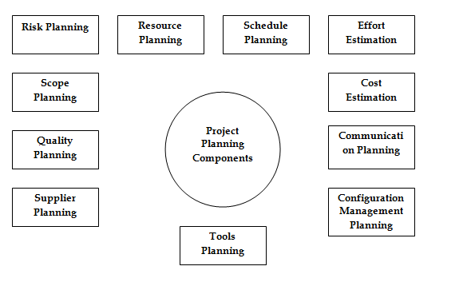

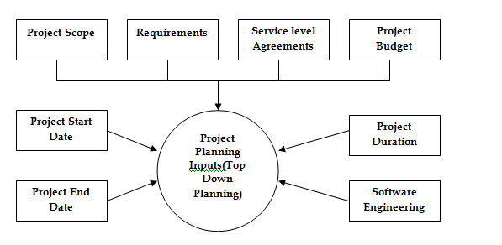

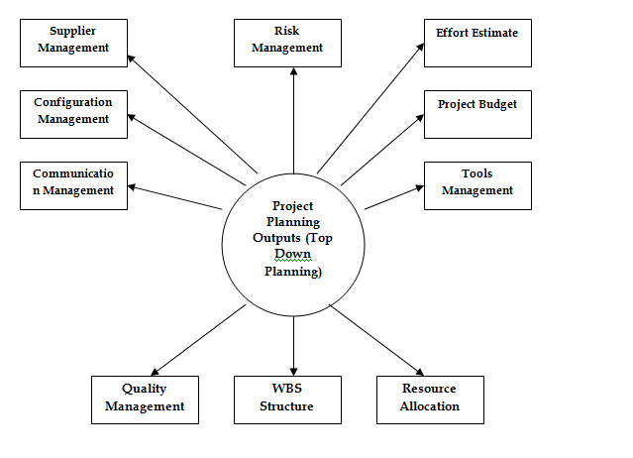

**Project scheduling**

* Split project into tasks and estimate time and resources required to complete each task.
* Organize tasks concurrently to make optimal use of workforce.
* Minimize task dependencies to avoid delays caused by one task waiting for another to complete.
* Dependent on project managers intuition and experience.

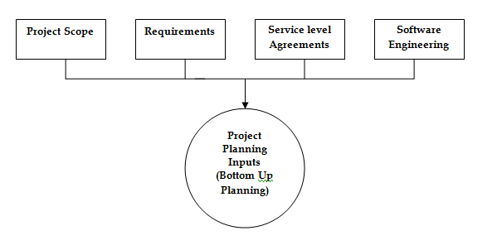

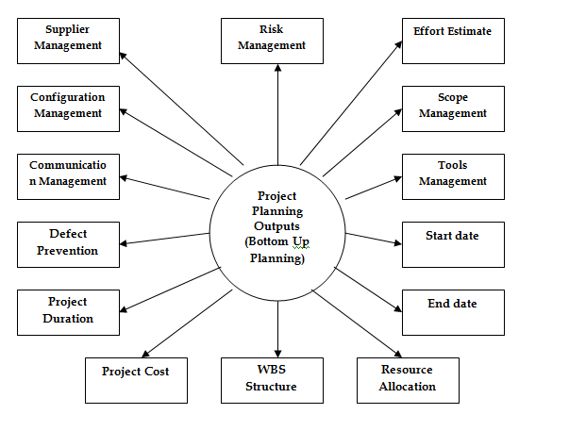

**Reflections on Case Study/course work:**

A person might gain important insights into their learning process and the real-world application of project management concepts by thinking back on case studies or project planning-related coursework. Some thoughts that one might have are as follows:

Comprehending the Significance of Planning: Studying project planning case studies or taking coursework on the subject emphasizes how important planning is to a project's success. I developed a greater understanding of the importance of careful planning in reducing risks, maximizing resources, and accomplishing project goals by examining actual situations or simulated projects.

Application of Project Management Tools and Techniques: Case studies and coursework often involve applying various project management tools and techniques, such as Gantt charts, risk matrices, and work breakdown structures (WBS). Reflecting on these experiences, I recognize the practical utility of these tools in facilitating project planning, communication, and decision-making.

Navigating Challenges and Uncertainties: Project planning exercises frequently present challenges and uncertainties that require creative problem-solving and adaptive thinking. Reflecting on how I approached these challenges, I realize the importance of flexibility, resilience, and collaboration in navigating unexpected obstacles and adjusting plans accordingly.

**Collaborative Learning:**

In our collaborative learning session, we delved into the intricacies of project planning, focusing particularly on its various components and methodologies. Here's a breakdown of what we discussed:

Baseline Structure Development: We emphasized the significance of establishing a comprehensive baseline structure during the project planning phase. This serves as the foundation upon which the entire project execution, monitoring, and control processes are built.

Project Components Elaboration: We meticulously elaborated on all the essential project components, including project scheduling, budgeting, manpower planning, communication planning, and quality planning. Each component plays a crucial role in ensuring the success of the project and must be meticulously planned and executed.

Project Scheduling Methods: We explored two primary approaches to project scheduling: top-down planning and bottom-up planning. In top-down planning, we discussed the allocation of time duration for the entire project first, followed by breaking down tasks into smaller increments within the time frames of their respective overarching tasks. Conversely, in bottom-up planning, we highlighted the process of assigning time durations to smaller tasks first, which are then aggregated to determine the time duration for larger tasks.

**Further Research/Readings:**

After class did further research and readings on project planning that offer an opportunity to delve deeper into various aspects of this critical phase in project management. Did reading on

Project Management Books: Books authored by renowned project management experts provide in-depth insights into project planning methodologies, best practices, and case studies. Titles such as "A Guide to the Project Management Body of Knowledge (PMBOK® Guide)" by the Project Management Institute (PMI) and "Project Management: The Managerial Process" by Clifford F. Gray and Erik W. Larson offer comprehensive coverage of project planning concepts.

Academic Journals: Academic journals in the field of project management publish research articles, case studies, and theoretical papers on various aspects of project planning. Journals like the International Journal of Project Management and the Project Management Journal feature scholarly contributions that can deepen understanding and provide new perspectives on project planning practices.

**Peer Interactions:**

In our software project management class, we had a lively peer interaction session where we discussed that critical thinking helps challenge assumptions underlying project plans. By engaging in constructive debate and questioning each other's assumptions, team members can uncover biases, explore alternative approaches, and refine project plans to improve their robustness and effectiveness.

**Applications in Real Projects:**

Real-world applications of project planning are abundant across various industries and sectors. Here are a few examples of how project planning is applied in real projects:

Construction Projects: In construction projects, project planning involves defining project scope, creating work breakdown structures (WBS), scheduling tasks, allocating resources, and setting milestones. For example, before breaking ground on a new building, construction project managers meticulously plan every aspect, from obtaining permits to scheduling subcontractors, to ensure timely and cost-effective completion.

Software Development Projects: In software development projects, project planning includes defining project requirements, creating development timelines, allocating resources, and identifying potential risks. Agile methodologies like Scrum or Kanban are often used to plan and execute software development projects, allowing teams to adapt to changing requirements and deliver incremental updates.

Event Planning: Event planning involves detailed project planning to ensure that events are executed smoothly and successfully. Event planners create timelines, coordinate with vendors, manage budgets, and oversee logistics to bring events to fruition. Whether it's a corporate conference, wedding, or music festival, effective project planning is essential for managing all aspects of the event.

Infrastructure Projects: Infrastructure projects such as building roads, bridges, or public transportation systems require meticulous project planning to manage complex logistics and ensure safety and compliance. Project planners must consider factors such as environmental impact, stakeholder engagement, regulatory requirements, and budget constraints to deliver infrastructure projects on time and within budget.

Product Launches: Launching a new product requires comprehensive project planning to coordinate activities across multiple departments, including marketing, sales, product development, and supply chain management. Project planners develop launch timelines, allocate resources, manage budgets, and coordinate cross-functional teams to ensure a successful product launch.

**Adjustments to Goals:**

Complete 6th chapter in 4th week. Also project pitch in class.

**Goals for the Next Week:**

Next week midterm and going to work on project.